**Operators**

import java.util.Scanner;

class AQEB3 {

public static void main(String[] args)

{

System.out.println("Arthematic Operators");

int a=10;

int b=9;

System.out.println("Addition "+(a+b));

System.out.println("substration "+(a-b));

System.out.println("Multiplication "+(a*b));

System.out.println("Division "+(a/b));

}

}

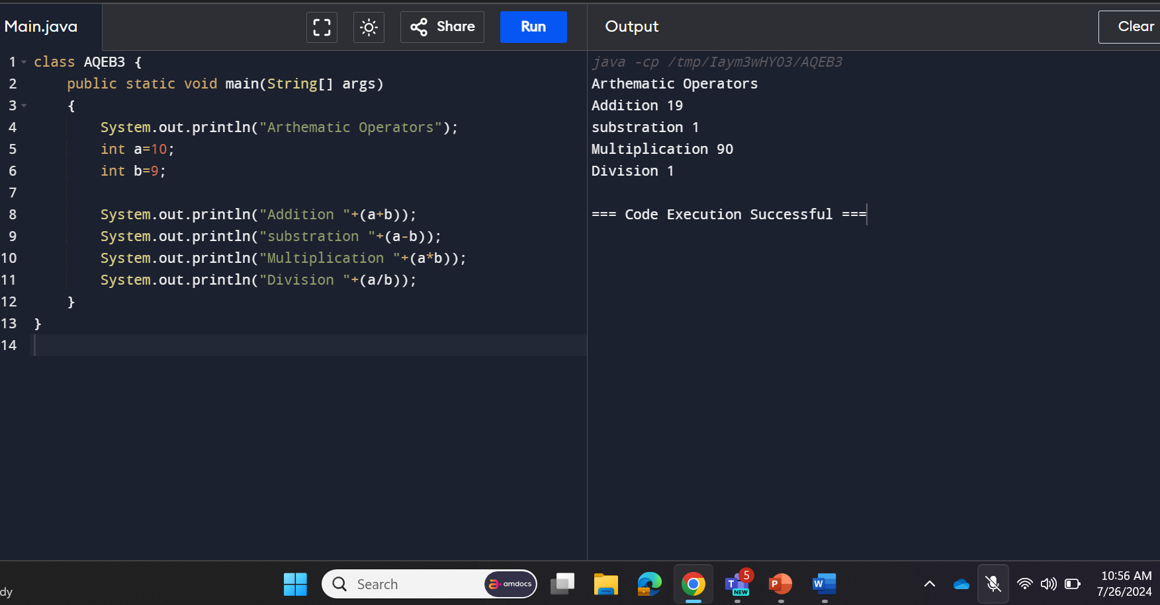

public class RelationalOperators {

public static void main(String[] args) {

int a = 10;

int b = 5;

System.out.println("a > b = " + (a > b));

System.out.println("a < b = " + (a < b));

System.out.println("a == b = " + (a == b));

System.out.println("a != b = " + (a != b));

System.out.println("a >= b = " + (a >= b));

System.out.println("a <= b = " + (a <= b));

}

}

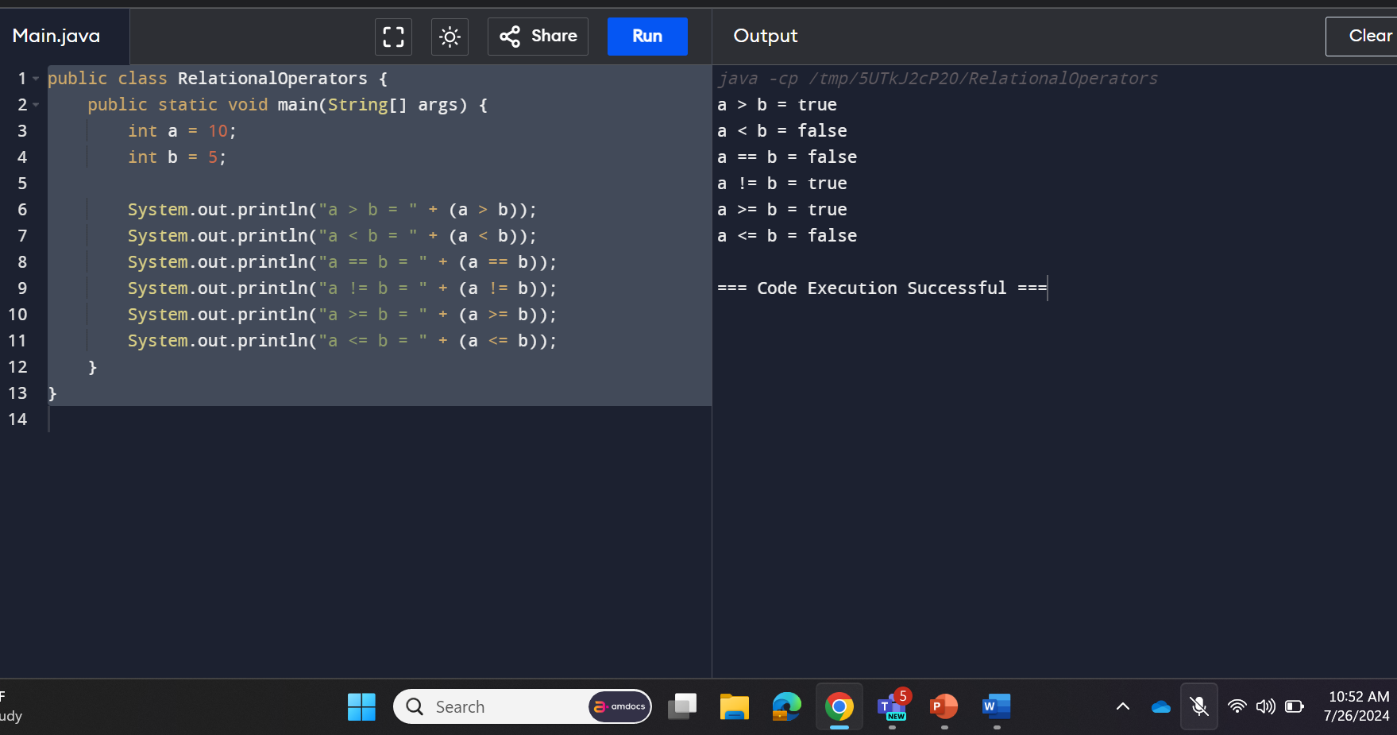

public class BitwiseOperators {

public static void main(String[] args) {

int a = 5;

int b = 3;

System.out.println("a & b = " + (a & b));

System.out.println("a | b = " + (a | b));

System.out.println("a ^ b = " + (a ^ b));

System.out.println("~a = " + (~a));

System.out.println("a << 1 = " + (a << 1));

System.out.println("a >> 1 = " + (a >> 1));

}

}

